1. Once you have the software, launch PuTTY and you will see the following screen:

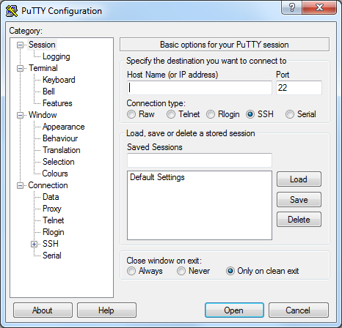

2. In the "Host Name (or IP address)" field, type: "access.engr.oregonstate.edu" and select open:

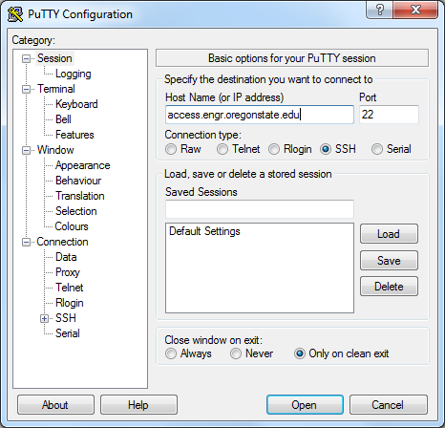

3. Type in **your** ONID user name and press enter:

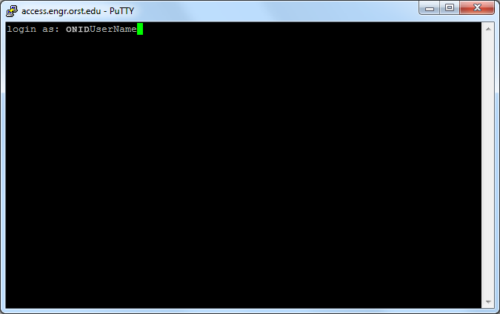

4. Type in your ONID password and press enter. **Note:** Your password will not appear as you type it:

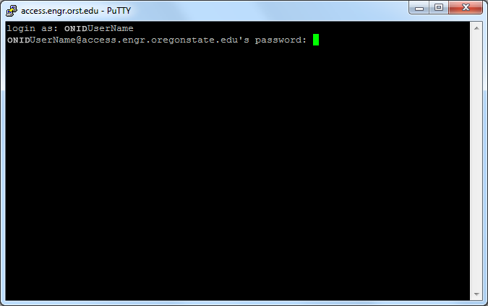

5. PuTTY will prompt you to select the terminal type. Select the default (xterm) by pressing enter:

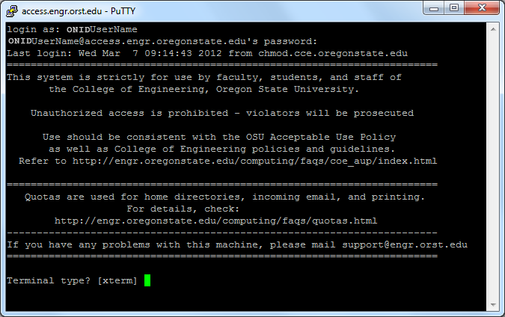

6. You are now connected to a UNIX terminal, at your home directory, from here you can access files using UNIX commands, or run UNIX applications. (Hint: Type "ls" then press return to see a list of the files in your home directory)

